UBMS ConXions  From the editor:  Now it is my second newsletter, so still be kind and still let me know if there are other things you would like to see each month. We had a good month both in social and business terms. Please send me some information and photos If you attend anything related to Rotary if I am not there. |  |  |  |  |  |   March
UPCOMING GUEST SPEAKERS  - 9/4/24: Paul Rogers talking 'Ethics'.  - 16/4 Jenny Hartnett - Membership  - 30/4 Chris Webber - Risk taking in the Blue Mountains  - 7/5 Ian Chappell - Australian Rotary Health  - 14/5 Ian Kirk - 'Go for broke' bike challenge.  UPCOMING EVENTS  - DCaf 2nd and 16th April  - Dinner at Sanwiye Korean Restaurant 23rd April  - Vanuatu visit will now be in June  - Woollies BBQ 13/4/24 | ABCD UPDATE  The pics below were sent by Phill in early March so all is progressing well as you can see below. Though there are no pictures yet it is now in lockup stage with windows and doors installed.
 | 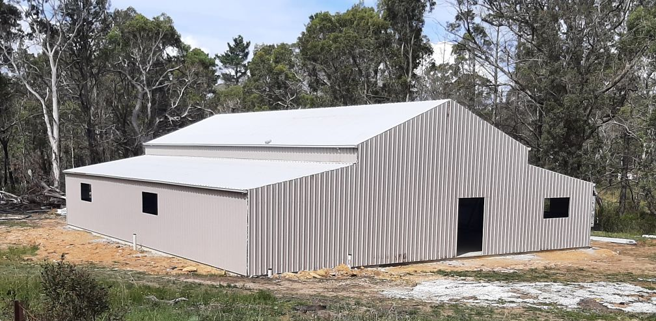
 | 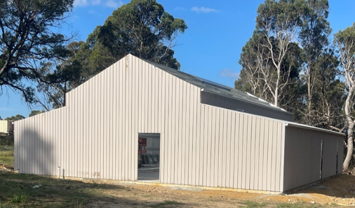 |  |  | 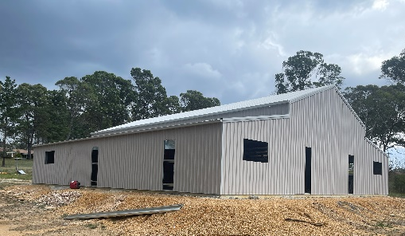
 | 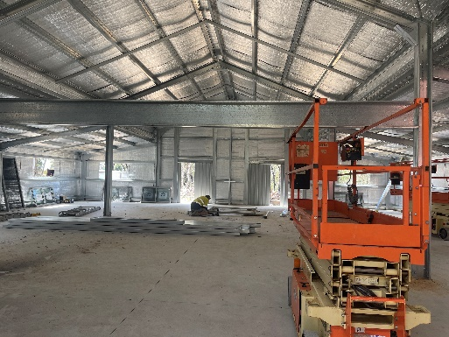 |  |  |  | 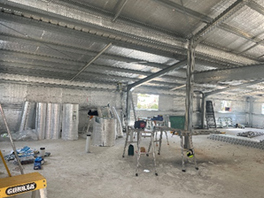
ROTARY DISTRICT CONFERENCE 15TH & 16TH MARCH

A fun time was had by our 3 members who attended the dinner on the Friday night, I hear Phill in particular set the dance floor a blaze! Our 8 members who attended the conference on the Saturday said the speakers were interesting and they enjoyed the more compact style.

2
UBMS ConXions March

INTERNATIONAL WOMEN’S DAY

Katoomba High Schools Womenkind Breakfast was very well attended. Everyone was made very welcome and offered a very tasty breakfast, compliments of the school’s enthusiastic hospitality group.

The panel for the day was varied: Bianca Nogrady, a science writer; Ailie Banks, an illustrator, designer, activist and violence prevention worker; Nina Kilpinen, managing director of Seed Engineering; and the key note speaker was Shanell Dargan, current Australian Super Bantam Weight Boxing Champion.

Shanell spoke about how life can take you to unexpected places if you are open to new ideas. It was an interesting talk, focussing on the amazing things you can achieve if you are determined and have lots of drive and enthusiasm. After her talk we heard a little from each of the very interesting and successful panel members, before an enthusiastic Q and A session.

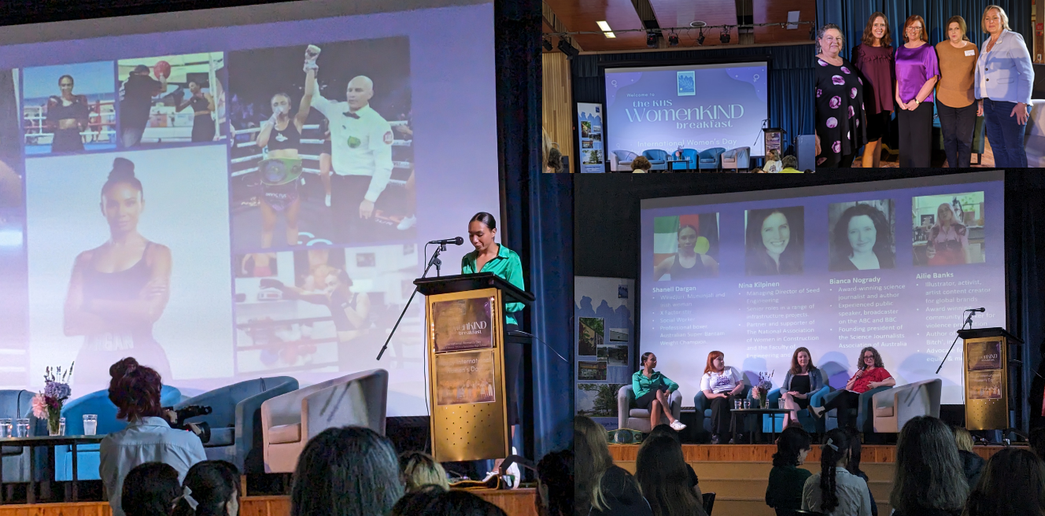
ROTARY YOUTH LEADERSHIP AWARDS  Bethany Mercy, an HIA Australian Apprentice of the Year, recently attended the Rotary Youth Leadership Awards. On the 25th March Beth spoke to our meeting about the life changing RYLA program for young people, and her advocacy to help get more young people into a career in the trades. Beth has completed her carpentry apprenticeship with Blue Mountains Eco Homes and is now working towards getting her builder’s licence. |  | 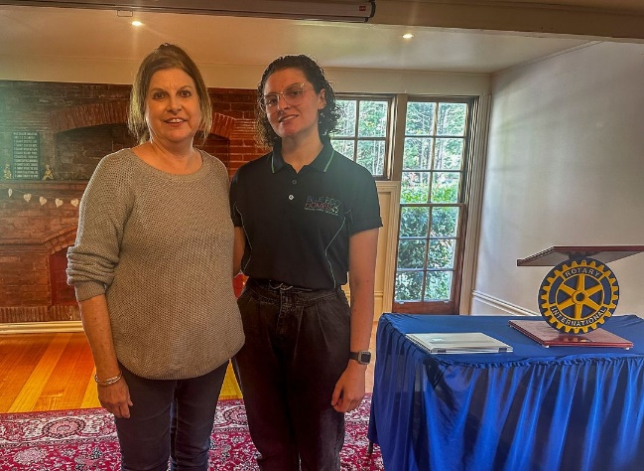  Photo and info curtesy of Ann Margulis
3
UBMS ConXions March

VISIT TO DRY RIDGE WINERY 24/3/24

This was great day out with the weather perfect for a trek down to The Megalong Valley. The company was very convivial, the food very tasty, the wines were quite varied and the view memorable. I really enjoyed the first wine, the Charlotte Prosecco and the last wine, the Alexander Pinot Noir.

Many thanks to Jenny for organising the outing before the deluge, and for picking up Margaret, she had a big day out as you can see with Michael’s montage of their trip home on the next page.

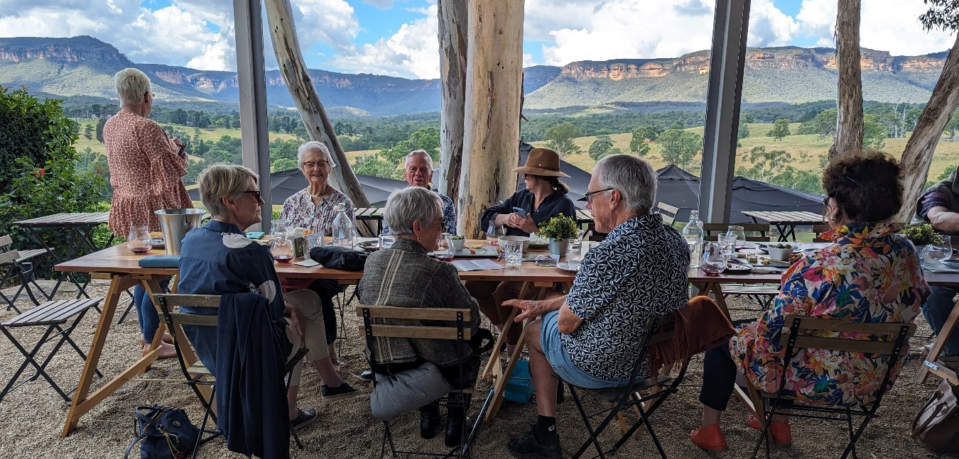
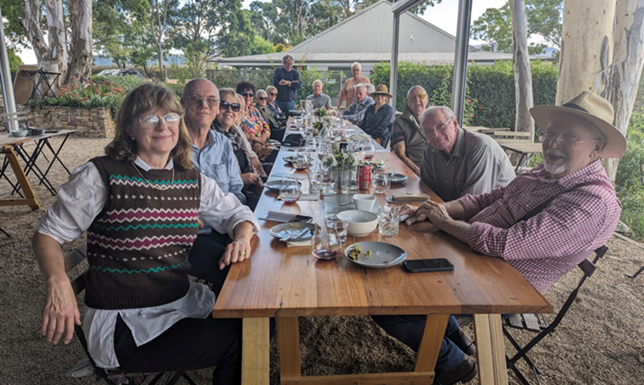

4
UBMS ConXions March

MICHAELS’ MONTAGE

Michael had an epic trip taking Margaret home after the Winery visit, as his montage below shows. He has now replaced his blown-up radiator, but not without the usual issues associated with getting all the required parts in a timely way. Michael is very appreciative of all the help given on the day.

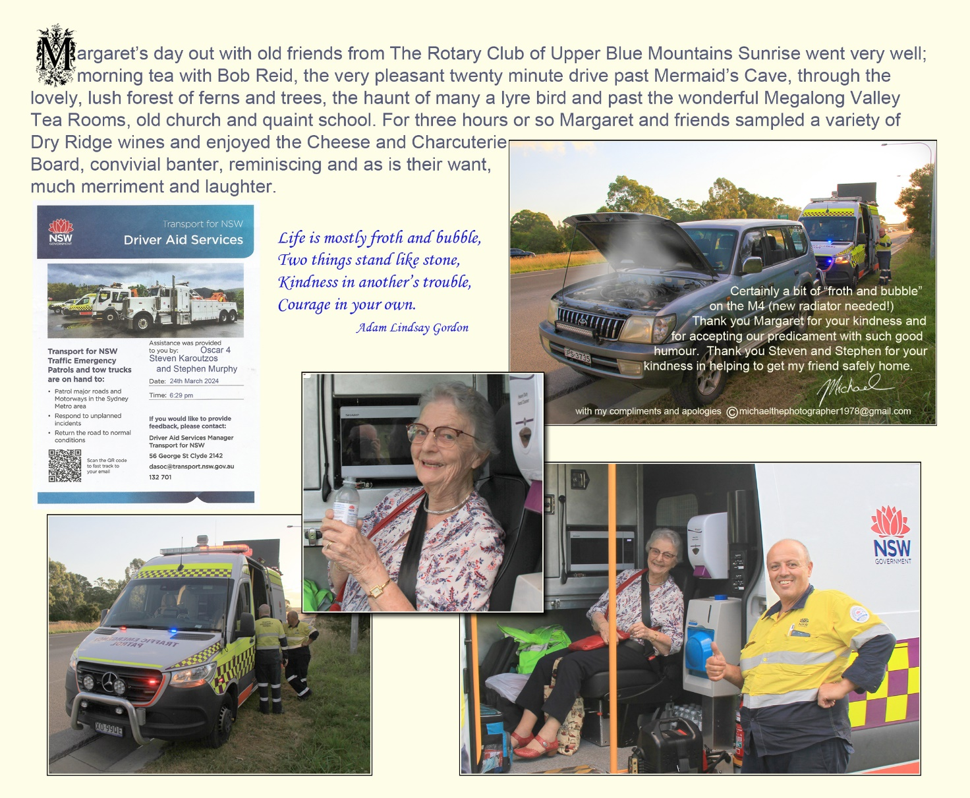

A big thankyou to Michael for also remaining in good humour when his good turn finished up being such a marathon. It was great to see Margaret, and without enthusiastic drivers like Jenny and Michael it would not have happened. I also know that Bob was delighted with the visit for morning tea earlier in the day.

5
UBMS NEWSLETTER February
BACKPAGE

- Regionalisation update: The Clubs in our group are Blackheath, Katoomba, Upper Blue, Central Blue, Springwood, Lower Blue, Richmond, North Richmond Kurrajong, Penrith, Penrith Valley, Nepean, St Mary’s and Windsor. Each Club will retain its independence, but will have the support of a number of specialists. It is as a way for Clubs to work together even more than in the past. We can get together and work on projects which are common to all in our grouping, including fundraising projects. Where there are shortages of members to work on a particular project in one Club, they can call on support from the other Clubs.
- We will vote for our new group RCL and the results will be announced on April 23. Training for the RCL will be on May 16 by Zoom and face to face over the weekend of May 22/23. Then the RCG will become active July 1 for the new Rotary Year.
- David Wallace gave a talk on photography to the Central Blue Rotary meeting. He showed a number of pictures from the 1960s to the present.
- Phill and Jenny attended president elect training on 23rd March

- Birthday wishes for a happy, healthy year ahead go out to our March and April children: Joan Hart, Paul Armstrong, Rod Tout, and Peter Shehadie.

Winner of competition 1: to find a name for our newsletter

The prize went to Rod Tout for ConXions

WORD AND NUMBER PUZZLES

A jar of blackberry jam to the first member to email me the correct answers

- word in the anagram: finable ice
- use of all of the following numbers: 50, 75, 4, 7, 5, and 100; to arrive at a solution of 450. (each number can be used only once, processes can involve any combinations of basic math: x, /, +, -)

Answers for February
- hypnotist shoes = photosynthesis
- 25 x 8 = 200
3 x 50 = 150
200 + 150 + 100 = 450 - 1 = 449


