UBMS ConXions  From the editor:  This a special changeover edition, we welcome in our new Presidents, Jennifer Hartnett and Phill Isaacs, and wish them a productive year ahead. As always please let me know if you have any information you want added. |  |  |   June/July
UPCOMING GUEST SPEAKERS  - 30th July Club Assembly  - 6th August Linda Kemp, Empty Bowls Project; and Les Margulis about his visit to RI  - 13th August Mike Greenslade, CEO ShelterBox (Zoom | CHANGEOVER AT LILIANFELS RESORT
 | Our new presidents for 2024/25 are seen to the right already working well together.  Our combined changeover with Katoomba was a great success, everyone seemed to have a very enjoyable time. Special mention goes to our award winners, shown below receiving their awards. | 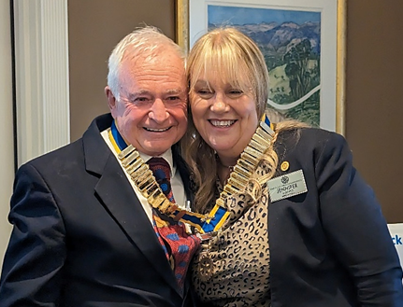
UPCOMING EVENTS  - DCaf dates are 23rd July and 6th August  - Vanuatu visit being rescheduled  - Woollies BBQs 10/8/24  - Social at Phill’s 23/7 at 6pm  - 31st July is The Pollice Officer of the Year Dinner at Katoomba RSL | 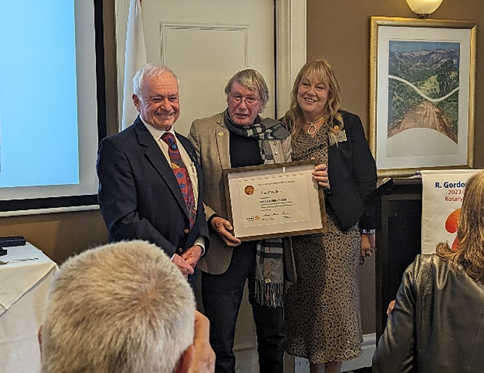  David Wallace receiving his first Paul Harris Fellowship Award

2
UBMS ConXions June/July

MORE CHANGEOVER AWARDS

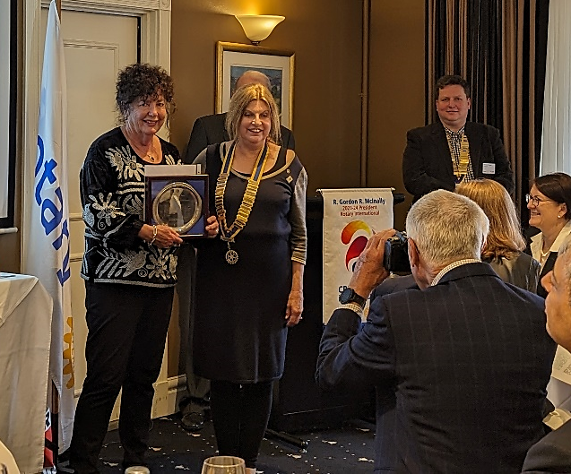  Liz Romalis receiving her Rotarian of the Year Award | 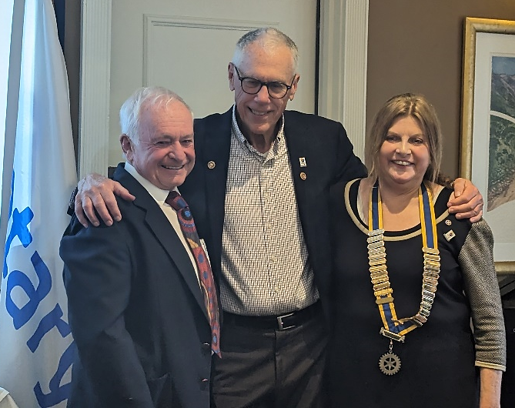  Bill Pixton was awarded his second Paul Harris Fellowship Award
The prestegious Paul Harris Fellowship was also awarded to the ABCD Coordinator, Dennis Jones for his dedication and time commitment that he put into the reconstruction of The Bell, Clarence and Dargen Community Hall.  After accepting the award Dennis introduced his supportive team members, shown bottom right. | 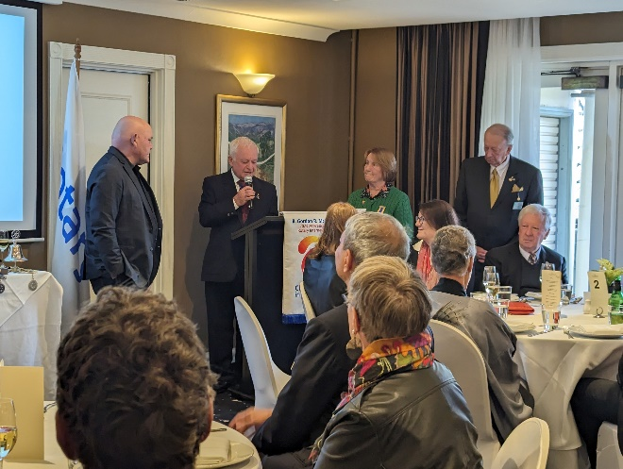
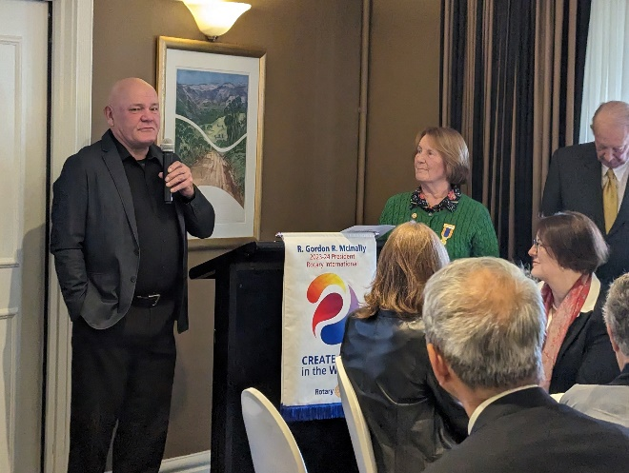 | 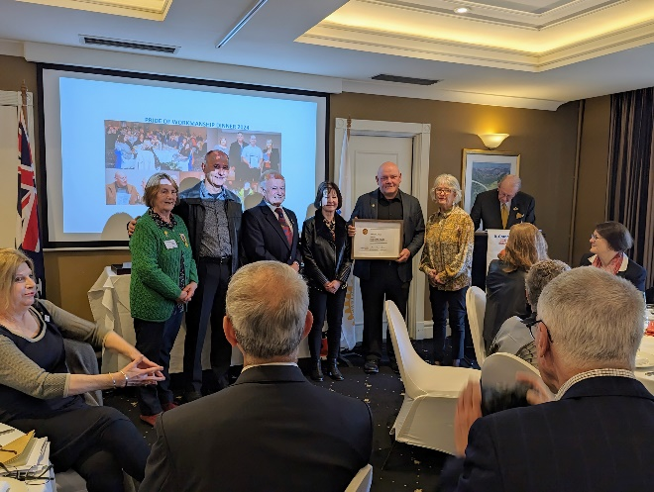

3
UBMS ConXions June/July

MORE CHANGEOVER PICTURES
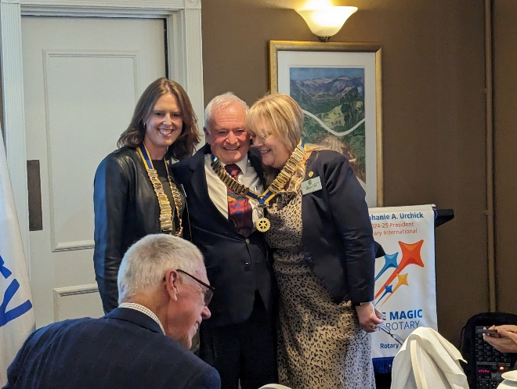  The three new presidents Faye Woodward from Katoomba Rotary with Jenny and Phill | 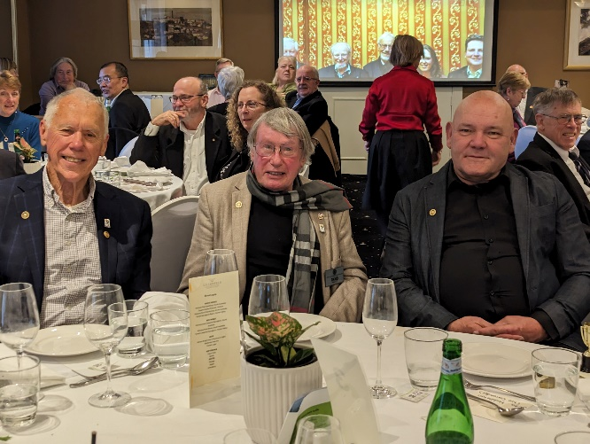  Our Three Paul Harris awardees, Bill Pixton, David Wallace and Dennis Jones celebrating together
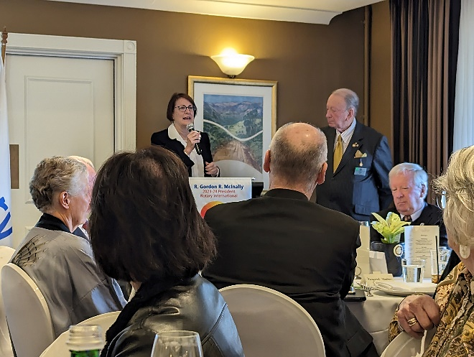  Susan Templeman MP addressing the audience. | 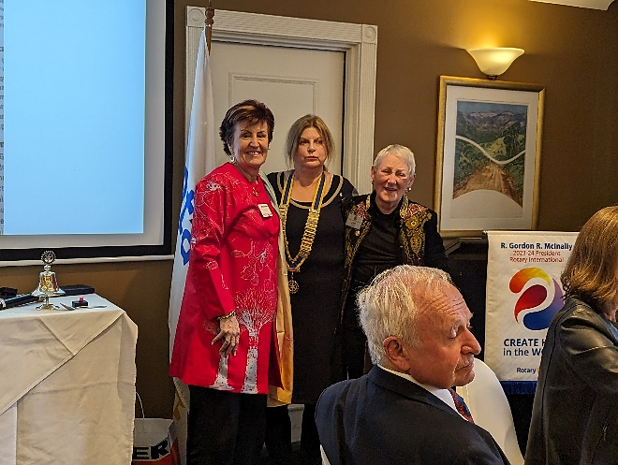  Michelle Ellery and Sandra de Gruchy thanking Ann for her hard work organising the day.
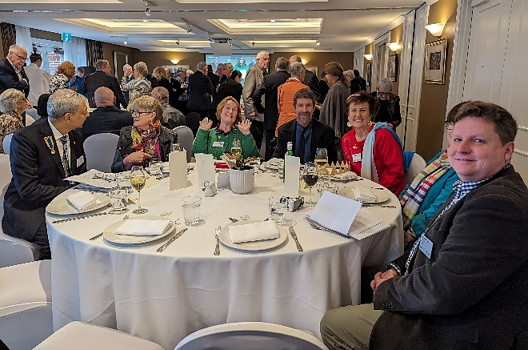  Some special guests, including DG Niranjan Deodhar, District Governor Nominee and RCL Michele Ellery, DGE John Campbell, and PDG Mina Howard who did a heartwarming Welcome to Country, are sitting with Katoomba past president Michael Skeggs. | 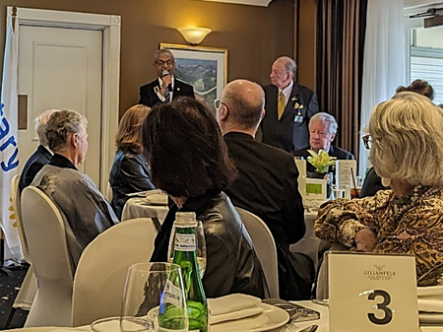  DG Niranjan Deodhar toasting Rotary International

4
UBMS ConXions June/July

OUR MEMBERS RECEIVE ENVIRONMENTAL AWARDS
Our hardworking environmentalists have been recognised for their ongoing hard work in various areas of the mountains. They recently received three Rotary Enviroclub Awards, two Silver and one Bronze.  They mostly work with the National Parks, weeding, planting and doing track maintenance. Some of their work involves: | 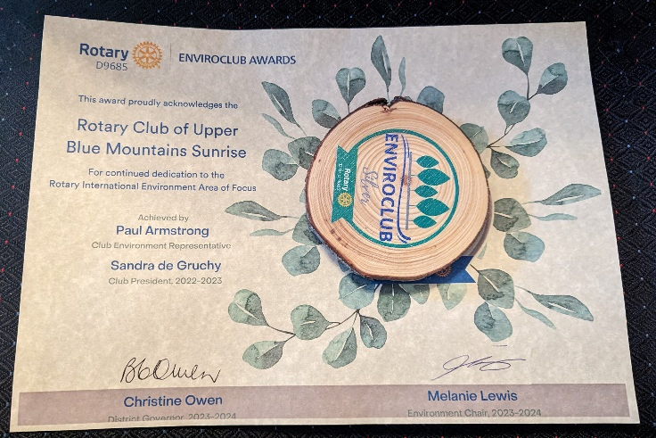
- weeding in the Blackheath area by Bill Pixton, Paul Armstrong and Sue Armstrong
- planting in Green Gully area of Megalong Valley by Phill Isaacs and Paul Armstrong. This has been an ongoing project for the past 15 years
- weeding and track maintenance in the Leura area mainly by Phill Isaacs
- weeding in Euroka Clearing, Glenbrook once a month by Paul and Sue Armstrong
- Sue and Paul have also started a weeding and planting project in Lomatia Park Springwood. In the past year they have spent 200 hours filling 110 Green Bins with weeds, and planting close to 100 plants

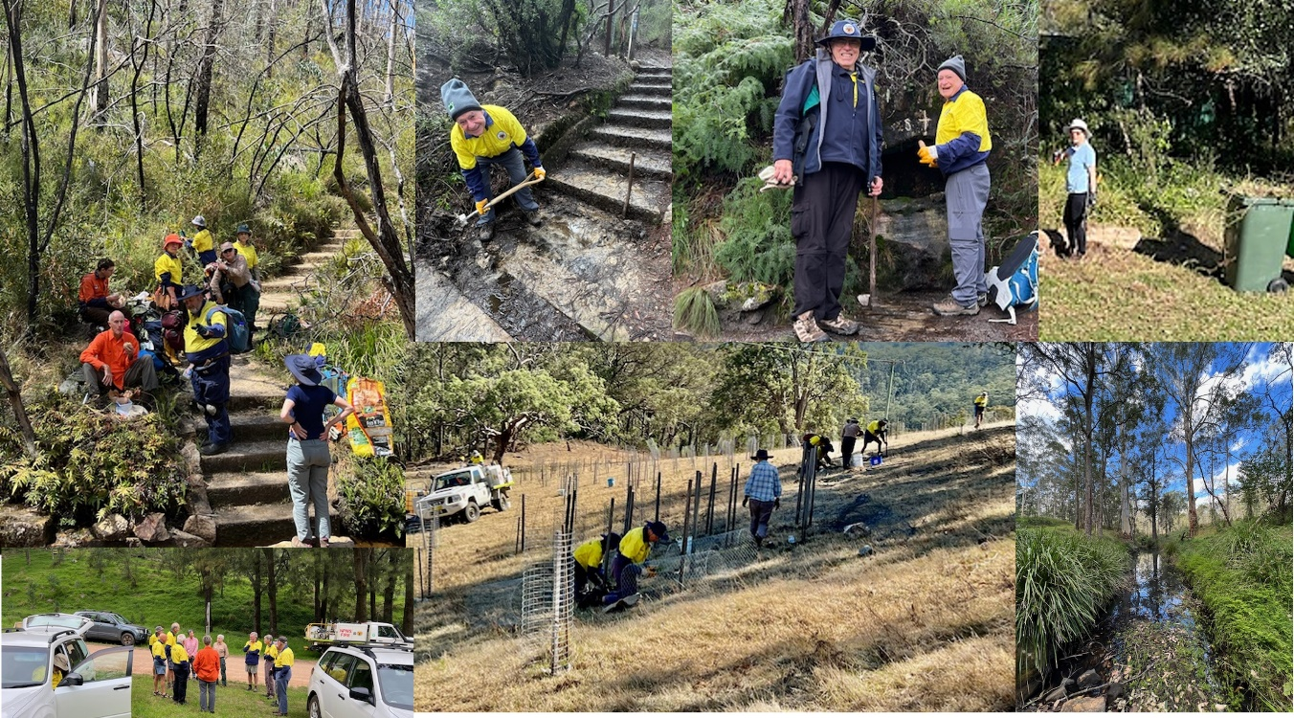
Its great to see their dedication and hard work acknowledged

5
UBMS ConXions June/July

SOME RECENT GUEST SPEAKERS
Chris Smith started his journey with shared reading in England and has now got a group operating in the Mountains.  Chris spoke passionately about the importance of shared reading. He explained how it was different to a book club and how using a reading exercise can help start conversations within the group.  He is always looking for volunteers if you are interested in getting involved | 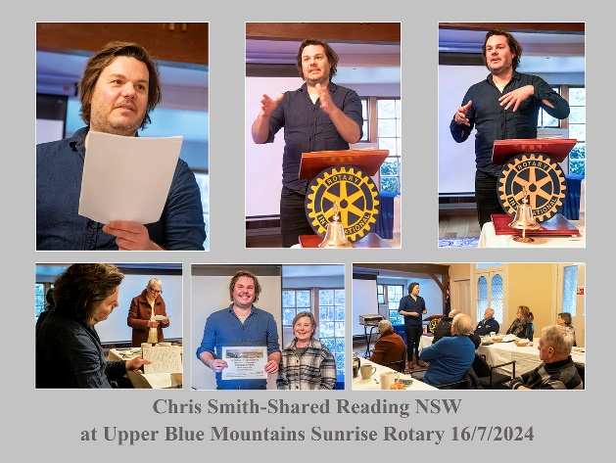
On the 7th July John Campbell spoke about business connections and defibrillator mapping. John spoke about the importance of have good business connections with your Rotary club and gave great advice about how to achieve this.  John also spoke about an App project that maps the location of defibrillators. This App is easy to download and can be lifesaving. | 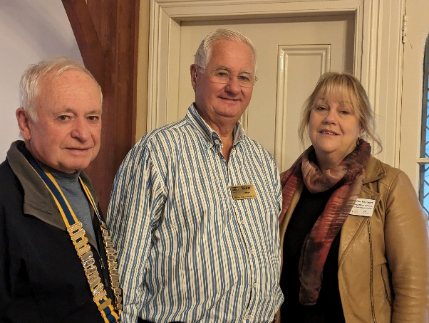
On the 25th June Chris Stanley from CRISP, The Community Refugee Integration and Support Program spoke about the great work they do.  Settling into a new community where you do not speak the language is very challenging, particularly in the Mountains where there are no large refugee populations. CRISP work with volunteers to help reduce the pressure. | 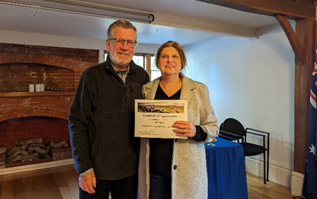
Our own Pat Drummond sings a song he wrote to thank Sandra for her year as President. The audience was given the job of chorus singers and Sandra being a former Primary School teacher really appreciated the musical send off. | 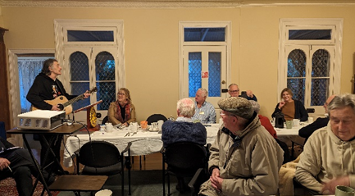

6
UBMS ConXions June/July

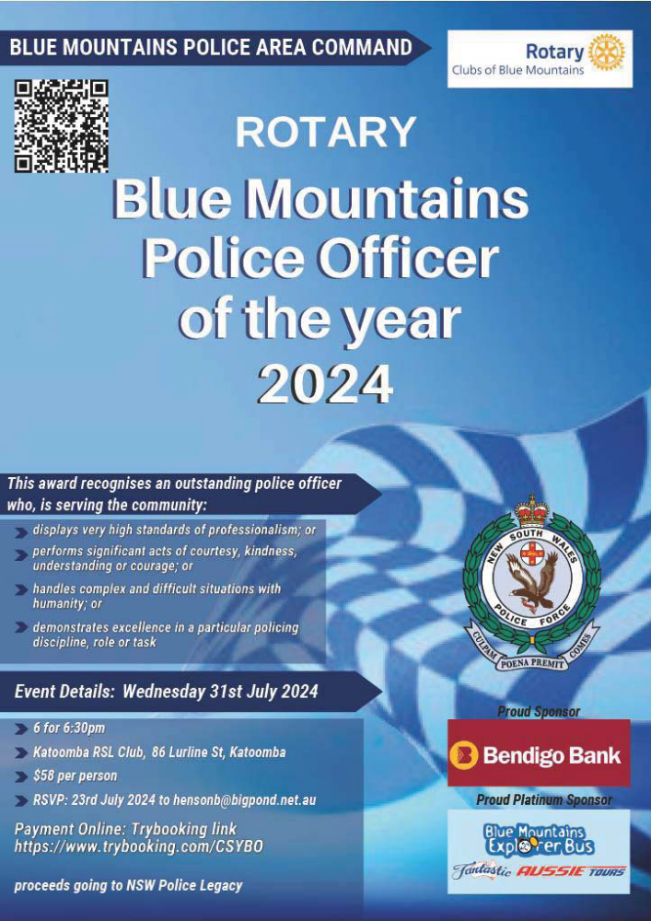

7
UBMS ConXions June/July

BACKPAGE

- The July BBQ was a great success raising just a few dollars short of $1000, a big thanks to everyone who helped out
- Phill is resolving the Vanuatu visit so the visit is on again, just awaiting the details
- One of Ann’s Bonsais has been accepted in a Bonsai competition
- Our social with the Nepean breakfast club at the Ori was a rousing success. The food was good, though very generous and there was a great deal of info exchanged. Photo to the right  - The number puzzle will only use 4 numbers from now on to make it a little less challenging.  ifer  - Birthday wishes for a happy, healthy year ahead go out to our July and August children: David Hart, Les Margulis, and Liz Romalis | 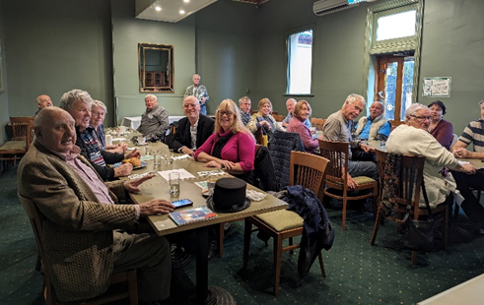
Winner of April/May Puzzles: congrats to Jennifer Hartnett for solving the word puzzle and almost getting the number puzzle

JUNE/JULY WORD AND NUMBER PUZZLES

A jar of blackberry jam to the first member to email me the correct answers

- word in the anagram: nerd sip fish
- use of all of the following numbers: 50, 25, 6, and 9; to arrive at a solution of 221. (each number can be used only once, processes can involve any combinations of basic math: x, /, +, -)

Answers for APRIL/MAY
- mark ship now = workmanship
- 100 – 50 = 50; 50 X 8 = 400
400 / 4= 100; 100 - 25 = 75
75 X 7 = 525


